|  |  |
| --- | --- |
|  | **2012** |
|  | Belorussian State University of Informatics and Radioelectronix |

|  |
| --- |
| **[ipcamclientserver – Getting started]** |
| Setup of development environment for execution of IpCamClientServer |

Contents

Software Components Installation 2

K-Lite Codec Pack 8 Full 2

Opera 1152 2

Microsoft .Net Framework 3.5 SP1 2

Microsoft .Net Framework 4 (Full Profile) 2

Create Local Configuration 2

Launch Software 3

# Software Components Installation

## K-Lite Codec Pack 8 Full

K-Lite codec pack can be installed from **Environment\K-Lite_Codec_Pack_800_Full.exe**. It contains drivers required for IP-Camera Emulator work.

## Opera 1152

Opera can be installed from **Environment\Opera_1152_int_Setup.exe.** You can view MJPEG IP-camera video stream directly in this browser.

## Microsoft .Net Framework 3.5 SP1

In order to execute software Microsoft .Net Framework 3.5.1 (or 3.5 SP1) must be installed and enabled.

|  |  |
| --- | --- |
| Operating system | Required Steps |
| Windows 2003,  Windows XP,  Windows Vista,  Windows 2008,  Windows 2008 SP1,  Windows 2008 SP2 | 1. Install **Environment\Windows 2003, XP, Vista, 2008, 2008 SP1, 2008 SP2\Microsoft .Net Framework 3.5.exe**. 2. Reboot computer   If installation fails please ensure that Windows Updates service is running:   1. Click Start; 2. Type **services.msc** and press **Enter**; 3. Select **Windows Updates**, 4. Open service properties via context menu, 5. Set **automatic** launch type, 6. Click **Apply**, 7. Click **Start**, 8. Retry to install Microsoft .Net Framework 3.5 SP1. |
| Windows 7,  Windows 2008 R2 | 1. Click **Start**; 2. Type **appwiz.cpl** and press **Enter**; 3. Click **Turn Windows features on or off**; 4. Enable Microsoft .Net Framework 3.5.1 as on the picture below and then click OK. |

## Microsoft .Net Framework 4 (Full Profile)

In order to execute software please install **Environment\Microsoft .Net Framework 4 (Full Profile).exe**.

# Create Local Configuration

1. To start configuration please execute **setup.cmd**:

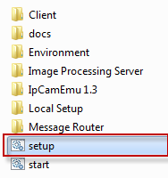

1. Enter windows password of logged in user and click Create

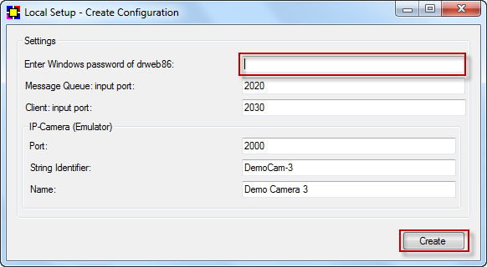

1. Done

# Launch Software

1. Execute **start.cmd**:

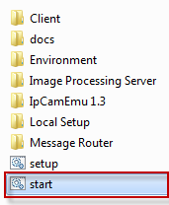

1. Wait until IP-Camera Emulator window becomes yellow and Message Router window is blue

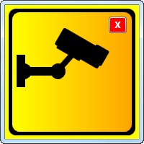



1. Start **Opera** browser
2. Paste <http://localhost:2000> in Opera address bar



1. Enter your **windows login and password** in popup that **Opera** will open
2. Done: now you see video from IP Camera Emulator in **Opera** tab
3. Switch to **Client**
4. Open **Report Tool** in Client

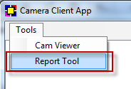

1. Connect to **Message Router** in **Report Tool**

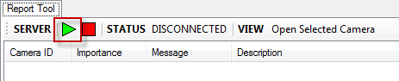

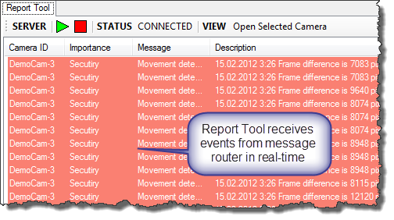

1. Open context menu on event and click Open Selected Camera:

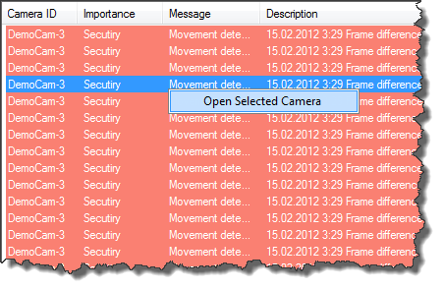

1. Camera Viewer Tool will be opened

